Unit 3. Learning with Regression
What is Regression:
Regression is a statistical approach used to analyze the relationship between a dependent variable (target variable) and one or more independent variables (predictor variables). The objective is to determine the most suitable function that characterizes the connection between these variables.
It is a supervised machine learning technique, used to predict the value of the dependent variable for new, unseen data. It models the relationship between the input features and the target variable, allowing for the estimation or prediction of numerical values.
It is mainly used for prediction, forecasting, time series modeling, and determining the causal-effect relationship between variables.
In Regression, we plot a graph between the variables which best fits the given datapoints, using this plot, the machine learning model can make predictions about the data. In simple words, "Regression shows a line or curve that passes through all the datapoints on target-predictor graph in such a way that the vertical distance between the datapoints and the regression line is minimum."
Some examples of regression can be as:
- Prediction of rain using temperature and other factors
- Determining Market trends
- Prediction of road accidents due to rash driving.
Terminologies Related to Regression Analysis:
- Dependent Variable: The main factor in Regression analysis which we want to predict or understand is called the dependent variable. It is also called target variable.
- Independent Variable: The factors which affect the dependent variables or which are used to predict the values of the dependent variables are called independent variable, also called as a predictor.
- Outliers: Outlier is an observation which contains either very low value or very high value in comparison to other observed values. An outlier may hamper the result, so it should be avoided.
- Multicollinearity: If the independent variables are highly correlated with each other than other variables, then such condition is called Multicollinearity. It should not be present in the dataset, because it creates problem while ranking the most affecting variable.
- Underfitting and Overfitting: If our algorithm works well with the training dataset but not well with test dataset, then such problem is called Overfitting. And if our algorithm does not perform well even with training dataset, then such problem is called underfitting.
Use Regression Analysis:
There are various scenarios in the real world where we need some future predictions such as weather condition, sales prediction, marketing trends, etc., for such case we need some technology which can make predictions more accurately. So for such case we need Regression analysis which is a statistical method and used in machine learning and data science. Below are some other reasons for using Regression analysis:
- Regression estimates the relationship between the target and the independent variable.
- It is used to find the trends in data.
- It helps to predict real/continuous values.
- By performing the regression, we can confidently determine the most important factor, the least important factor, and how each factor is affecting the other factors.
Types of Regression:

There are various types of regressions which are used in data science and machine learning. Each type has its own importance on different scenarios, but at the core, all the regression methods analyze the effect of the independent variable on dependent variables.

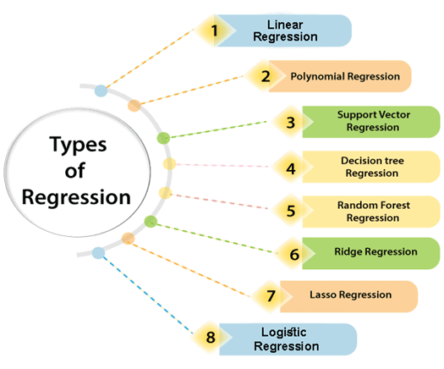

Linear Regression in Machine Learning:

Linear regression is one of the easiest and most popular Machine Learning algorithms. It is a statistical method that is used for predictive analysis. Linear regression makes predictions for continuous/real or numeric variables such as sales, salary, age, product price, etc.
Linear regression algorithm that provides a linear relationship between a dependent (y) and one or more independent (y) variables, hence called as linear regression. Since linear regression shows the linear relationship, which means it finds how the value of the dependent variable is changing according to the value of the independent variable.
Linear regression is not merely a predictive tool; it forms the basis for various advanced models. Techniques like regularization and support vector machines draw inspiration from linear regression, expanding its utility. Additionally, linear regression is a cornerstone in assumption testing, enabling researchers to validate key assumptions about the data.
The linear regression model provides a sloped straight line representing the relationship between the variables. Consider the below image:
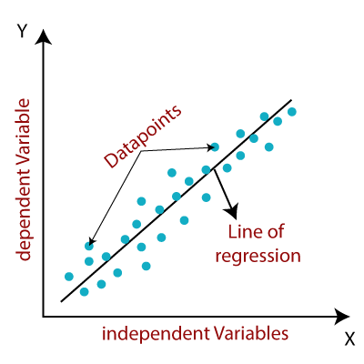
Best Fit Line for a Linear Regression Model

In the above figure,
X-axis = Independent variable
Y-axis = Output / dependent variable
Line of regression = Best fit line for a model
Here, a line is plotted for the given data points that suitably fit all the issues. Hence, it is called the ‘best fit line.’ The goal of the linear regression algorithm is to find this best fit line seen in the above figure.

Linear Regression Equation :
Y = m*X + c
Where X = dependent variable (target)
Y = independent variable
m = slope of the line
c = is the intercept

Linear regression can be further divided into two types of the algorithm:
Simple Linear Regression:
If a single independent variable is used to predict the value of a numerical dependent variable, then such a Linear Regression algorithm is called Simple Linear Regression.

Multiple Linear regression:
If more than one independent variable is used to predict the value of a numerical dependent variable, then such a Linear Regression algorithm is called Multiple Linear Regression.

Difference Between Linear Regression and Multiple Regression:
Parameter | Linear (Simple) Regression | Multiple Regression
Definition | Models the relationship between one dependent and one independent variable. | Models the relationship between one dependent and two or more independent variables.
Equation | Y = C₀ + C₁X + e | Y = C₀ + C₁X₁ + C₂X₂ + C₃X₃ + ….. + C_{n}X_{n} + e
Complexity | It is simpler to deal with one relationship. | More complex due to multiple relationships.
Use Cases | Suitable when there is one clear predictor. | Suitable when multiple factors affect the outcome.
Assumptions | Linearity, Independence, Homoscedasticity, Normality | Same as linear regression, with the added concern of multicollinearity.
Visualization | Typically visualized with a 2D scatter plot and a line of best fit. | Requires 3D or multi-dimensional space, often represented using partial regression plots.
Risk of Overfitting | Lower, as it deals with only one predictor. | Higher, especially if too many predictors are used without adequate data.
Multicollinearity Concern | Not applicable, as there’s only one predictor. | A primary concern; having correlated predictors can affect the model’s accuracy and interpretation.
Applications | Basic research, simple predictions, understanding a singular relationship. | Complex research, multifactorial predictions, studying interrelated systems.

Applications of Linear Regression

Linear regression is used in many different fields, including finance, economics, and psychology, to understand and predict the behavior of a particular variable. For example, in finance, linear regression might be used to understand the relationship between a company’s stock price and its earnings or to predict the future value of a currency based on its past performance.

Advantages & Disadvantages of Linear Regression

Advantages of Linear Regression
- Linear regression is a relatively simple algorithm, making it easy to understand and implement. The coefficients of the linear regression model can be interpreted as the change in the dependent variable for a one-unit change in the independent variable, providing insights into the relationships between variables.
- Linear regression is computationally efficient and can handle large datasets effectively. It can be trained quickly on large datasets, making it suitable for real-time applications.
- Linear regression is relatively robust to outliers compared to other machine learning algorithms. Outliers may have a smaller impact on the overall model performance.
- Linear regression often serves as a good baseline model for comparison with more complex machine learning algorithms.
- Linear regression is a well-established algorithm with a rich history and is widely available in various machine learning libraries and software packages.

Disadvantages of Linear Regression
- Linear regression assumes a linear relationship between the dependent and independent variables. If the relationship is not linear, the model may not perform well.
- Linear regression is sensitive to multicollinearity, which occurs when there is a high correlation between independent variables. Multicollinearity can inflate the variance of the coefficients and lead to unstable model predictions.
- Linear regression assumes that the features are already in a suitable form for the model. Feature engineering may be required to transform features into a format that can be effectively used by the model.
- Linear regression is susceptible to both overfitting and underfitting. Overfitting occurs when the model learns the training data too well and fails to generalize to unseen data. Underfitting occurs when the model is too simple to capture the underlying relationships in the data.
- Linear regression provides limited explanatory power for complex relationships between variables. More advanced machine learning techniques may be necessary for deeper insights.

